Logical Volume Manager (LVM) is a device mapper framework that provides logical volume management for the Linux kernel. The main advantage of LVM is that it can be used to extend a volume group without having to reformat the entire volume group, which would be required in the case of traditional linear volumes. This functionality is provided by using physical extents, which are blocks of underlying storage either on the same disk or on another disk.



**HOW TO CREATE LVM?**

**Traditional:**

**Partitions:** Disk Partitioning is the process of dividing a disk into one or more logical areas, often known as partitions, on which the user can work separately. It is one step of disk formatting. If a partition is created, the disk will store the information about the location and size.

**Limitations:**

* We cannot further extend that partition
* We can’t sum two partitions and create

**Advanced:**

**LVM: (Logical Volume manager):**

LVM’s are widely used for managing disk storage

It provides an abstraction layer between physical storage and file system

It enables file systems to be resized to span across multiple disks

It allows accumulating space taken from one or more several partitions to form volume group which is further divided into logical volumes

In the volume group there are a number of blocks, these are called Physical Extend (P. E)

Each Physical extend is 4mb (1 P. E = 4 MB).

In logical volume there are no. of blocks, these are called as Logical extend.

Primary benefits that LVM offer include the resizing of volume GRPS and logical volume, online data migration btw logical volume & physical volumes, user-defined naming for volume GRPS and logical volume, mirroring & striping across multiple physical disk and snap shooting of logical volumes

Creating a partition: List blocks

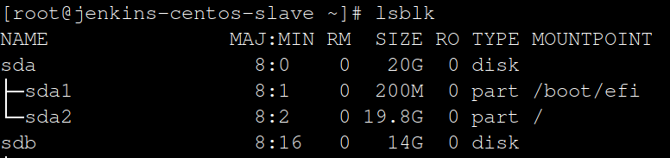

Create partition from sdb:

Syntax: fdisk <disk name>

[root@jenkins-centos-slave ~]# fdisk /dev/sdb

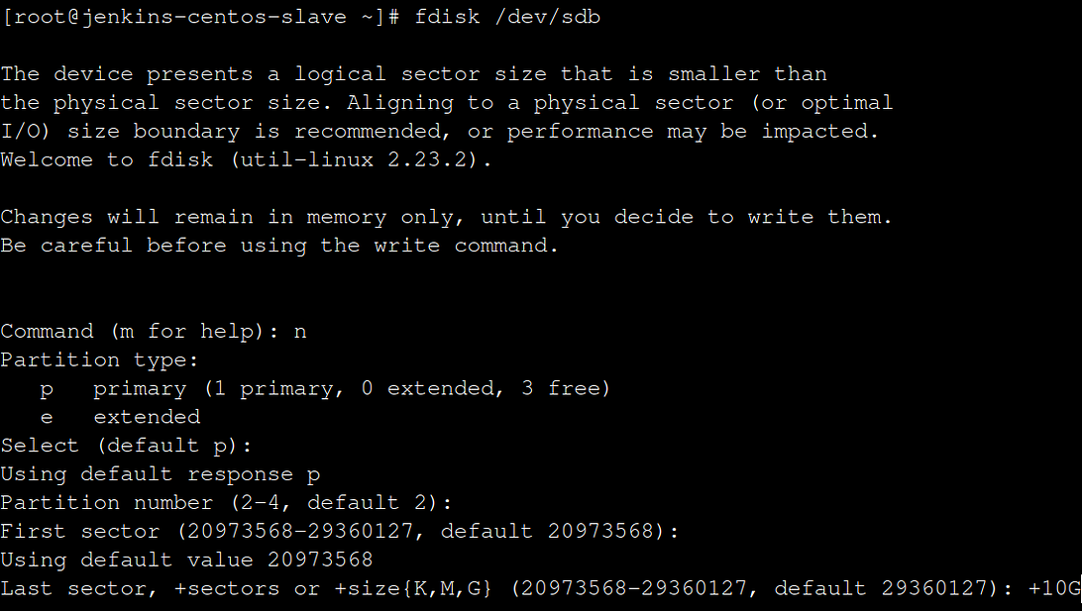

[root@jenkins-centos-slave ~]# lsblk

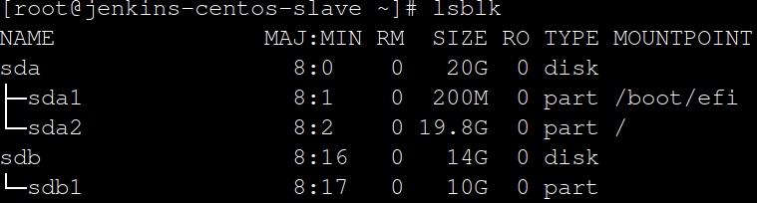

Create physical volume:

Syntax: pvcreate < disk name >

[root@jenkins-centos-slave ~]# pvcreate /dev/sdb1

[root@jenkins-centos-slave ~]# pvs

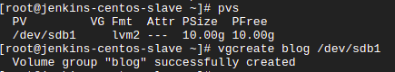

Create volume group:

Syntax: vgcreate -n < name of vg > -L < +G,M > < pvname >

[root@jenkins-centos-slave ~]# vgcreate blog /dev/sdb1

[root@jenkins-centos-slave ~]# vgs



[root@jenkins-centos-slave ~]# vgs

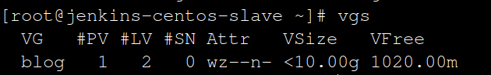

Create logical volume :

Syntax: lvcreate -n < name of lv > -L < +G,M > < pvname/vgname >

[root@jenkins-centos-slave ~]# lvcreate -n bloglv -L +5G /dev/blog

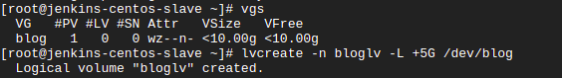

[root@jenkins-centos-slave ~]# lvs



[root@jenkins-centos-slave ~]# lsblk

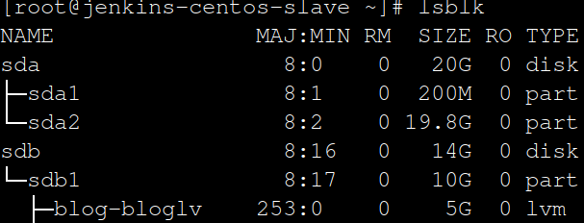

Format LVM disk:

Syntax: [root@jenkins-centos-slave ~]# mkfs. < filesystem > < lvm name >

[root@jenkins-centos-slave ~]# mkfs.xfs /dev/blog/bloglv

[root@jenkins-centos-slave ~]# blkid

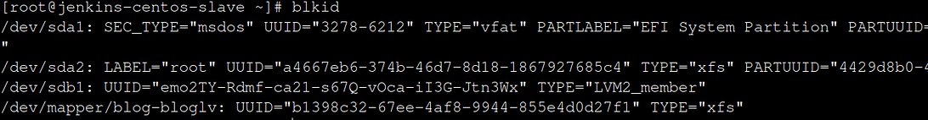

Create a directory:

[root@jenkins-centos-slave ~]# mkdir mount-point

Mount Directory to LVM:

[root@jenkins-centos-slave ~]# Mount /dev/blog/bloglv mount-point

[root@jenkins-centos-slave ~]# lsblk

